Exersice 12
devlop a geomatric diamension tool that store fixed height width and depth parameters of a shipping container inside a tuple uppacks the measurement and the compute the total valume in py
Code:
dimensions = (2.5, 2.4, 6.0)
height, width, depth = dimensions
volume = height * width * depth
print("Height:", height, "m")
print("Width:", width, "m")
print("Depth:", depth, "m")
print("Total volume:", volume, "cubic meters")
Output:
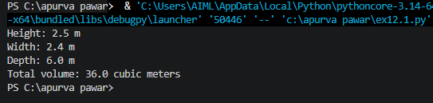

Que2: create a constant system logging profile that maps an IP adress alongside a server port number inside a tuple pair , demonstating that these setting remain secure from runtime modification attemps
Code:
LOGGING_PROFILE = ("192.168.1.100", 514)
server_ip, server_port = LOGGING_PROFILE
print("Server IP:", server_ip)
print("Server Port:", server_port)
try:
LOGGING_PROFILE[0] = "10.0.0.1"
except TypeError as error:
print("Modification blocked:", error)
print("Final profile:", LOGGING_PROFILE)
Output:
